**SDF LAB WEEK 4**

**Q1**

**CODE**

#include<stdio.h>

void main()

{

int a,b;

printf ("enter a no ");

scanf("%d", &a);

printf ("enter another no ");

scanf("%d", &b);

if (a>b)

printf("%d is greater than %d", a,b);

else printf("%d is greater than %d", b,a);

}

**OUTPUT**

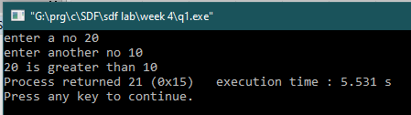

**Q2**

**CODE**

#include<stdio.h>

void main()

{

int a;

printf ("enter a no ");

scanf("%d", &a);

if (a>0)

printf("%d is positive",a);

else printf("%d is negative",a);

}

**OUTPUT**

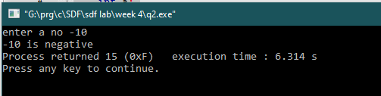

**Q3**

**CODE**

**#include<stdio.h>**

**void main()**

**{**

**int a;**

**printf ("enter a no ");**

**scanf("%d", &a);**

**if (a%2==0)**

**printf("%d is even",a);**

**else printf("%d is odd",a);**

**}**

**OUTPUT**

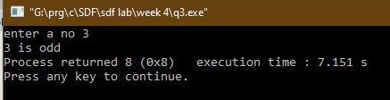

**Q4**

**CODE**

#include<stdio.h>

void main()

{

char a;

printf ("enter a character => ");

scanf("%c", &a);

if (a=='a'||a=='e'||a=='i'||a=='o'||a=='u'||a=='A'||a=='E'||a=='I'||a=='O'||a=='U')

printf("%c is a vowel ",a);

else printf("%c is a consonant",a);

}

**OUTPUT**



**Q5**

**CODE**

#include<stdio.h>

void main()

{

int a;

printf ("enter your age ");

scanf("%d", &a);

if (a>=18)

printf("you are eligible to vote");

else printf("you are not eligible");

}

**OUTPUT**

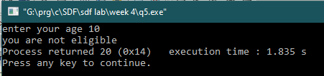

**Q6**

**CODE**

#include<stdio.h>

void main()

{

int a;

printf ("enter a year ");

scanf("%d", &a);

if (a%4==0)

printf("%d is a leap year",a);

else printf("%d is not a leap year",a);

}

**OUTPUT**

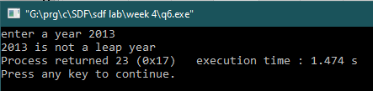

**Q7**

**CODE**

#include<stdio.h>

void main()

{

int a,b,c;

printf ("enter a no ");

scanf("%d", &a);

printf ("enter a no ");

scanf("%d", &b);

printf ("enter a no ");

scanf("%d", &c);

if (a>b && a>c)

printf("%d is greatest",a);

else if (a<b && b>c)

printf("%d is greatest",b);

else if (c>a && b<c)

printf("%d is greatest",c);

}

**OUTPUT**



**Q8**

**CODE**

#include<stdio.h>

void main()

{

int cs,ssc,m,e,h,t;

float avg;

printf ("enter marks in computer science ");

scanf("%d", &cs);

printf ("enter marks in social science ");

scanf("%d", &ssc);

printf ("enter marks in maths ");

scanf("%d", &m);

printf ("enter marks in english ");

scanf("%d", &e);

printf ("enter marks in hindi ");

scanf("%d", &h);

t=cs+ssc+e+h+m;

avg=t/5;

if (avg>=90)

printf("grade is A");

if (avg<90 &&avg >=80)

printf("grade is B");

if (avg<80 &&avg >=70)

printf("grade is C");

if (avg<70 &&avg >=60)

printf("grade is D");

if (avg<60 && avg >=40)

printf("grade is E");

if (avg<40)

printf("grade is F");

}

**OUTPUT**

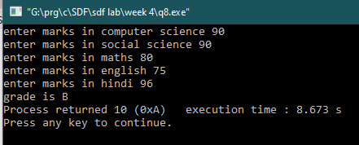

**Q9**

**CODE**

#include<stdio.h>

void main()

{

int rs;

printf("Enter the amount ");

scanf ("%d",&rs);

if (rs>500)

{

printf("\n no of Rs 500 notes required is %d",rs/500);

rs=rs%500;

}

if (rs>100)

{

printf(" \n no of Rs 100 notes required is %d",rs/100);

rs=rs%100;

}

if (rs>50)

{

printf("\n no of Rs 50 notes required is %d",rs/50);

rs=rs%50;

}

if (rs>20)

{

printf("\n no of Rs 20 notes required is %d",rs/20);

rs=rs%20;

}

if (rs>10)

{

printf("\n no of Rs 10 notes required is %d",rs/10);

rs=rs%10;

}

if (rs>5)

{

printf("\n no of Rs 5 coins required is %d",rs/5);

rs=rs%5;

}

if (rs>2)

{

printf("\n no of Rs 2 coins required is %d",rs/2);

rs=rs%2;

}

if (rs>1)

{

printf("\n no of Rs 1 coins required is %d",rs/1);

rs=rs%1;

}

}

**OUTPUT**

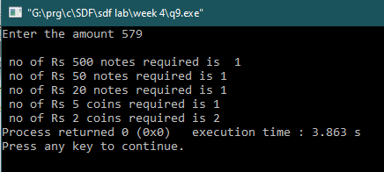

**Q10**

**CODE**

#include<stdio.h>

void main()

{

float sal,total, hra,da;

printf("enter the basic salary => ");

scanf("%f", &sal);

if (sal<=10000)

{

hra=sal*0.2;

da=sal*0.8;

total = sal+hra+da;

printf("\n the Basic Salary is %0.2f", sal);

printf("\n the HRA is %0.2f", hra);

printf("\n the DA is %0.2f", da);

}

if (sal>=10000 && sal <20000)

{

hra=sal*0.25;

da=sal*0.90;

total = sal+hra+da;

printf("\n the Basic Salary is %0.2f", sal);

printf("\n the HRA is %0.2f", hra);

printf("\n the DA is %0.2f", da);

}

if (sal>=20000)

{

hra=sal*0.3;

da=sal*0.95;

total = sal+hra+da;

printf("\n the Basic Salary is %0.2f", sal);

printf("\n the HRA is %0.2f", hra);

printf("\n the DA is %0.2f", da);

}

}

**OUTPUT**

